Busara Database Management System User Guide

Sudarshan Muralidhar

Installation and Setup

# Install XAMPP

XAMPP is a software suite that contains the necessary packages to start up and run a PHP MySQL application on your local machine. You can install it from here:  
<https://www.apachefriends.org/index.html>

Make sure the application is installed in the C:\xampp directory.

# Checkout Git Repository

Checkout the Git repository at <https://github.com/sudssm/Busara> using a Git command line or GUI client. If you do not have a Git client, you can simply download the zip export of the repository at <https://github.com/sudssm/Busara/archive/master.zip>

Extract this zip file to an accessible directory.

# Run Start.bat

Open up the main directory in Windows Explorer, and double click on start.bat

You should see output similar to the screenshot above. The line “IF 1==1 GOTO IMPORT” may be repeated several times – if so, just wait; this is a process waiting for your server to start up.

When everything is finished, your default browser should open up to the homepage of the application.

Import / Export

# Import

If you already have a .sql file that you would like to import, simply drag and drop the file to “import.bat” in Windows Explorer.

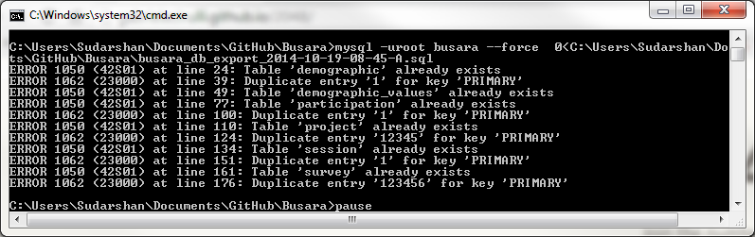You will see error messages for any records that could not be imported (usually because of duplicates in the current dataset).

# Export

Simply double click export.bat. The exported file will be written to the same directory as export.bat, in the following format: <busara_db_export_year-month-day-hour-min-A/P.sql>

Application Usage

In a browser, navigate to <http://localhost>. This is the location of the application.

Each of the pages listed on the index correspond to a page that allows for CRUD operations on the underlying MySQL database. The GUI should be fairly intuitive. If experiencing an issue, you can contact me at [sudarshan.muralidhar@gmail.com](mailto:sudarshan.muralidhar@gmail.com) with steps to recreate the problem. Opening up the browser’s javascript console will usually give error messages that could help isolate the issue.

For “Add Demographic” the admin password is “admin”. This can be modified by opening admin.php in a text editor, and modifying the line ‘$pw = "admin";’

MySQL command-line access can be gained by running “mysql –uroot” in a command prompt window.